Software Requirements Specification (SRS)
For Online DPC Module
1. Introduction
The Online DPC Module is to digitize the Departmental Promotion Committee (DPC) process for CGPSC, enabling secure, transparent, and efficient handling of promotion-related activities. The system will allow department heads, HR sections, and committee members to manage proposals, review employee records, conduct DPC meetings online, and record final promotion decisions.

2. Purpose of the Proposal
The proposal to CGPSC should aim to:
- Request formal approval and scheduling of the DPC meeting for a particular cadre/ department.
- Submit the list of eligible officers along with service records.
- Seek guidance or concurrence on promotion criteria.
- Ensure rule-based, auditable, transparent promotion decisions aligned with DoPT/ state guidelines.
2.1 Scope
The DPC module will:
- Automate proposal submission by departments.
- Maintain digital service records & ACR/APAR details of employees.
- Enable committee members to review cases and provide recommendations online.
- Support online DPC meeting scheduling & video conferencing.
- Generate promotion orders and maintain an audit trail.
- Provide role-based dashboards and reporting.
Users:
- Chairmain (CGPSC)
- DPC Committee Members
- Department Nodal Officer
- Department Establishment/ Employee of the Department
- IT Support Team
- Admin (CG PSC)

3. Functional Requirements
3.1 User Management
- Role-based access control (RBAC) with secure login (2FA).
- User creation & deactivation by Admin.
- Department-wise user mapping.
3.2 Employee Data Management
- Import from HRMS or manual entry.
- Fields: Employee ID, Name, Designation, Department, Date of Joining, Pay Scale, APAR/ACR ratings, disciplinary records, training details, service history.
3.3 Proposal Submission
- Department Nodal Officer uploads promotion proposal with supporting documents.
- Auto-validation for eligibility criteria (service years, APAR grading, etc.).
- Digital signature & time-stamping.
3.4 Review & Evaluation
- Committee members can view case files online.
- Add remarks, accept/reject with reasons.
- Automated scoring based on APAR & service history.
3.5 Online DPC Meeting
- Scheduling & agenda creation.
- Video conferencing integration (WebRTC / MS Teams / Zoom API).
- Digital note-taking during meeting.
- Real-time voting and decision recording.
3.6 Decision & Approval Workflow
- Final decision documented with committee members’ e-signatures.
- Auto-generation of promotion order.
- Notifications to concerned departments & employees.
3.7 Reports & Audit Trail
- Status-wise reports (Pending, Approved, Rejected).
- DPC meeting minutes & promotion list export (PDF/Excel).
- Complete audit trail of all actions.

4. Process Flowchart
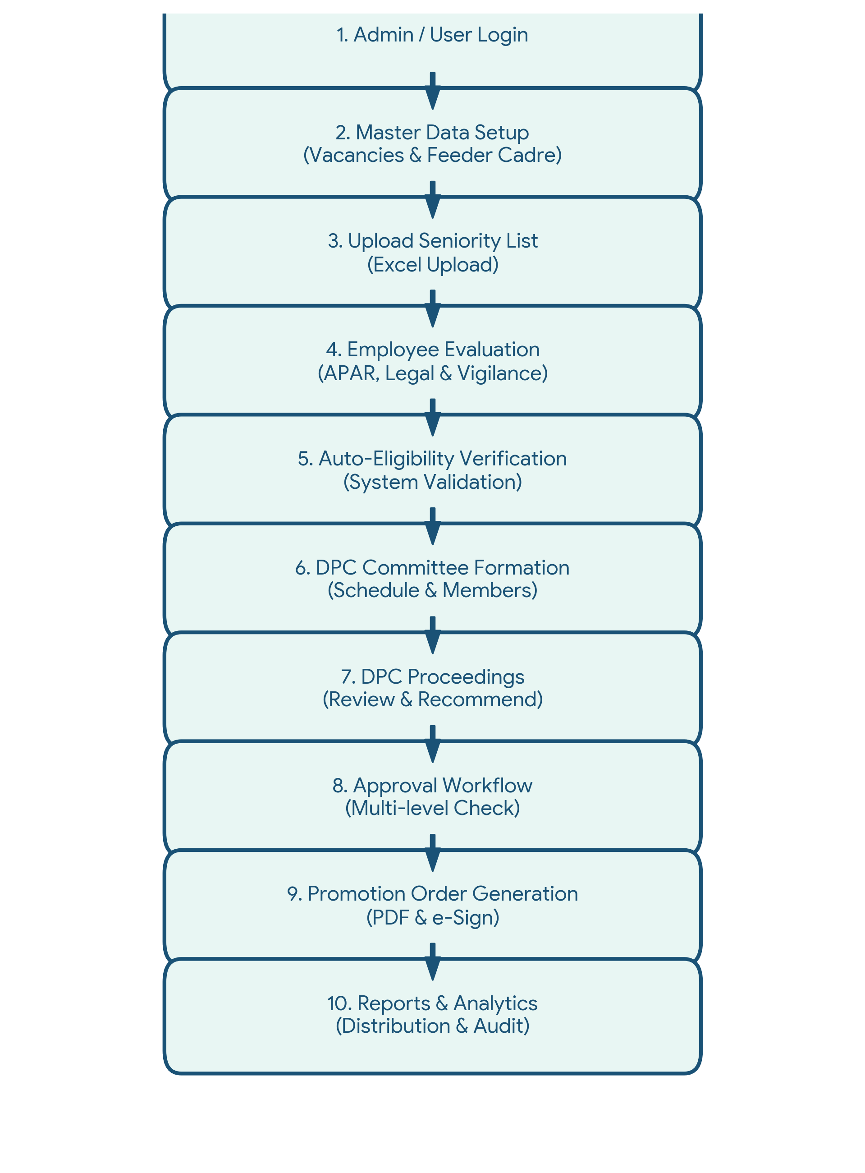
Module-wise Workflow
- Login → Role Selection
- Department Nodal Officer → Employee Search → Upload Proposal → Submit
- DPC Committee Member → View Proposals → Evaluate → Vote/Recommend
- Admin → Conduct Meeting → Record Minutes → Approve Decisions
- System → Generate Orders → Notify Departments & Employees

Module-wise Field Details
1. User Authentication (Screen 1)
Field Name | Type | Description
User ID / Employee ID | Text | Unique login ID for the user
Password | Password | Masked text for authentication
Select Role | Dropdown | Admin, Department User, Committee Member
Remember Me | Checkbox | To save the session locally
Login | Button | Action to authenticate

2. Dashboard Analytics (Screen 2)
Field Name | Type | Description
Metrics Cards | Display | Shows Total Vacancies, Eligible Officers, Pending DPC, Approved Promotions
Upcoming DPC Meetings | Data Grid | Lists Meeting No, Date, Department, and Status
Department-wise Vacancy | Bar Chart | Visual breakdown of Sanctioned, Working, and Vacant posts
Promotion Trend | Line Chart | 3-year historical data visualization
3. Vacancy Management (Screen 3)
Field Name | Type | Description
Department & Cadre | Dropdown | Select target department and cadre
Class | Dropdown | Employee class (e.g., Class-II)
Sanctioned Posts | Numeric | Total approved posts
Working Employees | Numeric | Currently active employees
Vacant Posts | Numeric (Auto) | Sanctioned - Working
Reservation Category | Numeric Grid | UR, SC, ST, OBC, EWS distribution
4. Feeder Cadre Management (Screen 4)
Field Name | Type | Description
Promotion Post | Dropdown | Target post for promotion
Feeder Post | Dropdown | Current/Source post
Minimum Service Required | Numeric | Required years of service
Recruitment Rule No | Text | Reference ID for the rule
Promotional Percentage | Numeric | Quota percentage allocated

5. Seniority List Management (Screen 5)
Field Name | Type | Description
Upload Seniority List | File Upload | Excel file format
Effective Date | Date Picker | Date list is effective from
Uploaded Seniority Lists | Data Table | Grid showing Uploaded On, Status, Action

6. Employee Evaluation (Screen 6)
Field Name | Type | Description
APAR Scores | Numeric | Rating points for previous years
Experience/Training Marks | Numeric | Points for experience and training
Integrity / Disciplinary | Radio | Yes/No confirmation
Total Score | Numeric | Auto-calculated sum

7. Legal & Vigilance Clearance (Screen 7)
Field Name | Type | Description
Court Case / Stay Order | Radio | Pending legal issues status
Vigilance Clearance | Dropdown | Cleared / Pending / Rejected
Upload Clearance Cert. | File Upload | PDF upload
Remarks | Text Area | Space for legal notes

8. DPC Committee Formation (Screen 8)
Field Name | Type | Description
Committee Name | Text | Name/ID of the committee
Meeting Date & Venue | Date/Text | Schedule details
Chairman & Members | Dropdowns | Assigned committee members

9. Eligibility Verification (Screen 9)
Field Name | Type | Description
Verification Criteria | Checklist Grid | System validations for APAR, Service, Legal, etc.
Eligibility Status | Label | Auto-generated: ELIGIBLE / NOT ELIGIBLE

10. DPC Proceedings (Screen 10)
Field Name | Type | Description
Committee Remarks | Text Area | Detailed meeting minutes
Recommendation | Radio Buttons | Recommended / Deferred / Rejected
Signed Proceedings | File Upload | Physical signed copy

11. Approval Workflow (Screen 11)
Field Name | Type | Description
Level & Approver | Display | Workflow stages and officials
Status & Date | Display | Approved/Pending timestamp

12. Promotion Order Generation (Screen 12)
Field Name | Type | Description
Promotion/Effective Date | Date Picker | Date configuration
Employee List | Data Grid | Read-only list of promoted employees
Generate PDF / e-Sign | Buttons | Draft and sign order
Publish Order | Button | Release final order

13. Reports & Analytics (Screen 13)
Field Name | Type | Description
Report Type | Dropdown | Select report type
From Date / To Date | Date Pickers | Date range selection
Export Excel / PDF | Buttons | Download format options

1. User Management Flow
Start
↓
Admin Login
↓
Create / Update / Deactivate User
↓
Assign Role & Department
↓
Send Login Credentials to User
↓
User Login → Role-Based Dashboard
↓
End

2. Employee Service Record Management Flow
Start
↓
Department Nodal Officer Login
↓
Search Employee in HRMS
├── Found → Auto-fetch details
└── Not Found → Manual Data Entry
↓
Fill Service Details (DOB, DOJ, Designation, APAR, etc.)
↓
Upload Supporting Documents
↓
Save & Submit
↓
End

3. Proposal Submission & Review Flow
Start
↓
Department Nodal Officer Selects Eligible Employee
↓
System Auto-Checks Eligibility Criteria
├── Eligible → Proceed
└── Not Eligible → Stop & Notify
↓
Fill Promotion Proposal Form
↓
Attach Supporting Docs
↓
eSign & Submit to DPC
↓
Committee Member Login
↓
Review Proposal & Service Record
↓
Give Recommendation (Approve/Reject/Defer)
↓
End

4. Online DPC Meeting Flow
Start
↓
Admin / Chairperson Login
↓
Schedule Meeting (Date, Time, Agenda, VC Link)
↓
Select Proposals for Review
↓
Send Notifications to Members
↓
Conduct Meeting (Video Conferencing + Digital Notes)
↓
Record Voting & Remarks
↓
Save Minutes of Meeting
↓
End

5. Final Decision & Order Generation Flow
Start
↓
Chairperson Reviews Meeting Outcomes
↓
Approve / Reject / Defer Proposals
↓
System Auto-Generates Promotion Orders (PDF)
↓
eSign by Authorized Officer
↓
Send Notifications to Departments & Employees
↓
Update Status in Reports
↓
End

